Install ROS nmea_navsat_driver enhanced driver

* Log into the Tractor
* $ cd catkin_ws/src
* $ git clone https://github.com/ros-agriculture/nmea_navsat_driver.git
* $ cd ..
* From ~/catkin_ws, $ catkin_make
* $ source devel/setup.bash
* $ rospack find nmea_navsat_driver # returns /home/al/catkin_ws/src/nmea_navsat_driver
* Launch sublime and open nmea_serial_driver.launch
* 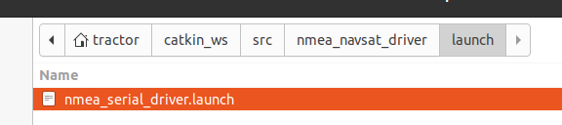
* $ cd /home/tractor/catkin_ws/src/nmea_navsat_driver/launch
* Update the gps port and baud input info
  + Open FileZilla
  + Go to /home/ubuntu/catkin_ws/src/nmea_navsat_driver/launch
  + Edit nmea_serial_driver.launch - a udev rule for “gps” needs to be in place

| From | To |
| --- | --- |
| <arg name="port" default="/dev/ttyUSB0" />  <arg name="baud" default="4800" /> | <arg name="port" default="/dev/gps" />  <arg name="baud" default="115200" /> |

* $ roslaunch nmea_serial_driver.launch

Trying the non-ROSAG version

* Log into the Tractor
* $ cd catkin_ws/src
* Delete the previous version
* Trying, $ git clone <https://github.com/ros-drivers/nmea_navsat_driver.git>
* $ cd ..
* From ~/catkin_ws, $ catkin_make

| Failed  -- Could NOT find catkin_virtualenv (missing: catkin_virtualenv_DIR)  $ sudo apt-get install ros-noetic-catkin-virtualenv |
| --- |
| #### Running command: "make -j2 -l2" in "/home/tractor/catkin_ws/build"  ####  Scanning dependencies of target nmea_navsat_driver_generate_virtualenv  [ 25%] Generate virtualenv in /home/tractor/catkin_ws/build/venv  True  [ 50%] Install requirements to /home/tractor/catkin_ws/build/venv  ERROR: launchpadlib 1.10.13 requires testresources, which is not installed.  [ 75%] Prepare relocated virtualenvs for develspace and installspace  [100%] Per-package virtualenv target  [100%] Built target nmea_navsat_driver_generate_virtualenv  tractor@tractor-HP-ProBook-645-G1:~/catkin_ws$  sudo apt install python3-pip |

* $ source devel/setup.bash
* $ rospack find nmea_navsat_driver # returns /home/al/catkin_ws/src/nmea_navsat_driver
* Launch sublime and open nmea_serial_driver.launch
* 
* Make sure power is turned on to the GPS board and there are lights associated with receiving satellite signals

| If you need to add a debug statement to print the nmea sentences  Folder: /home/ubuntu/catkin_ws/src/nmea_navsat_driver/src/libnmea_navsat_driver  Program: driver.py  rospy.loginfo("nmea_string: %s", nmea_string) # added line 163 for debugging |
| --- |

* $ roslaunch nmea_serial_driver.launch

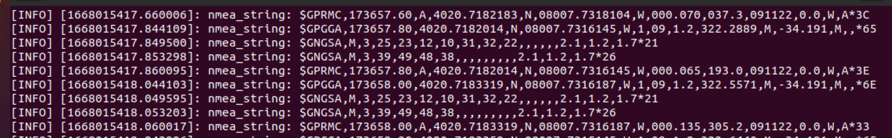

Comparing ROSAg and ROS

| ROS Ag  <https://github.com/ros-agriculture/nmea_navsat_driver/blob/master/src/libnmea_navsat_driver/driver.py> | ROS  <https://github.com/ros-drivers/nmea_navsat_driver/blob/master/src/libnmea_navsat_driver/driver.py> |
| --- | --- |
|  | [nmea_navsat_driver/driver.py at master · ros-drivers/nmea_navsat_driver · GitHub](https://github.com/ros-drivers/nmea_navsat_driver/blob/master/src/libnmea_navsat_driver/driver.py) |
|  |  |
| This is not committed  Note: <https://docs.ros.org/en/jade/api/sensor_msgs/html/msg/NavSatStatus.html>  int8 STATUS_SBAS_FIX = 1 # with satellite-based augmentation  int8 STATUS_GBAS_FIX = 2 # with ground-based augmentation |  |

GPS Quality indicator:

0: Fix not valid

1: GPS fix

2: Differential GPS fix, OmniSTAR VBS

4: Real-Time Kinematic, fixed integers

5: Real-Time Kinematic, float integers, OmniSTAR XP/HP or Location RTK

This was in my startup procedures:



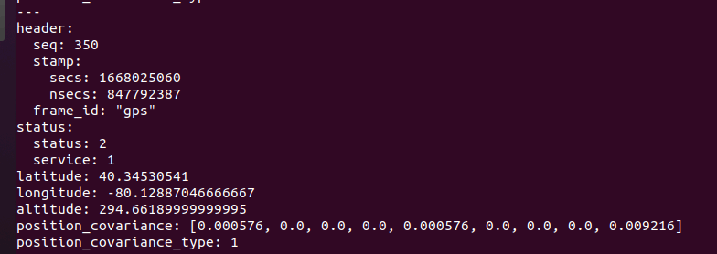

It suggests to me a “status” of 2 equates to a “good” RTK fix

You could try and use plotjuggler to plot the LAT/LON and see the drift

OLD NOTES FOR REFERENCE ONLY

Reference: <https://github.com/ros-agriculture/nmea_navsat_driver>

The base driver has been enhanced to publish speed and heading.

On Rpi:

* PuTTy into RPi $ plink RPI_on_ZeroTier -pw ubuntu
* $ cd catkin_ws/src
* $ git clone https://github.com/ros-agriculture/nmea_navsat_driver.git
* cd ..
* From ~/catkin_ws, $ catkin_make
* $ source devel/setup.bash
* $ rospack find nmea_navsat_driver # returns /home/al/catkin_ws/src/nmea_navsat_driver
* $ cd /home/ubuntu/catkin_ws/src/nmea_navsat_driver/launch
* Update the gps port and baud input info
  + Open FileZilla
  + Go to /home/ubuntu/catkin_ws/src/nmea_navsat_driver/launch
  + Edit nmea_serial_driver.launch

| From | To |
| --- | --- |
| <arg name="port" default="/dev/ttyUSB0" />  <arg name="baud" default="4800" /> | <arg name="port" default="/dev/gps" />  <arg name="baud" default="115200" /> |

* $ roslaunch nmea_serial_driver.launch

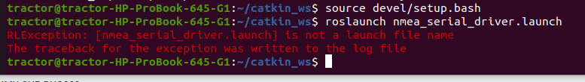

If you need to add a debug statement to print the nmea sentences

Folder: /home/ubuntu/catkin_ws/src/nmea_navsat_driver/src/libnmea_navsat_driver

Program: driver.py

rospy.loginfo("nmea_string: %s", nmea_string) # added line 163 for debugging

Check the GPGGA sentence after the longitude to see what the status is. The example below is “0”; I had to start the RTK base station and move the tractor outdoors.

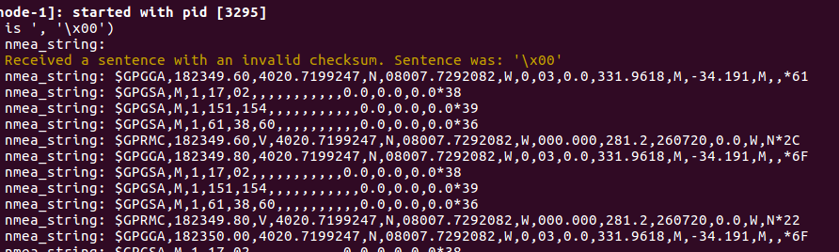

Afterwhich I am getting a 4 for status with 9 satellites.

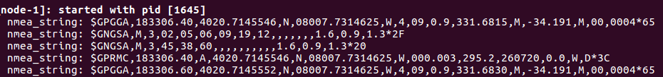

$ rostopic echo /fix

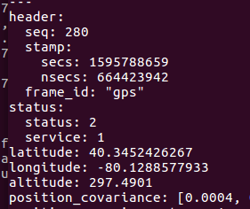

Power up the base station sending correction data

Power up the tractor gps

$ roslaunch /home/tractor/catkin_ws/src/nmea_navsat_driver/launch/nmea_serial_driver.launch

11/19/22

Gps-odom uses “import geonav_transform.geonav_conversions as gc”

<https://get-help.robotigniteacademy.com/t/no-module-name-geonav-transform-geonav-conversions/14494/5>

| $ cd /home/tractor/catkin_ws/src  $ git clone https://github.com/bsb808/geonav_transform.git  $ cd /home/tractor/catkin_ws/  $ catkin_make  $ source devel/setup.bash; rospack profile |
| --- |

Above did not produce errors, but gps_odom.py could not find library

$ python gazebo_elestero_ex.py

python3 -m pip install "SomeProject"

python3 -m pip install "geonav_transform"

